1. Write a C++ program to calculate the membership fee for a gym. The program should prompt the user to enter the age and duration of their membership (in months). The membership fee will be calculated according to the following table:

|  |  |
| --- | --- |
| **Age** | **Monthly Fee** |
| <18 | $50 |
| 18<= and <=25 | $70 |
| >25 | $100 |

**Sample Run:**

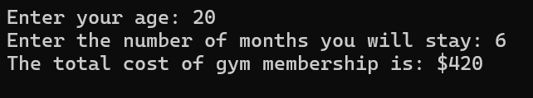

1. Create a C++ program for designing the *boxVolume()* function with default arguments to calculate a box’s volume. The function prototype for *boxVolume()*  specifies that all three parameters have default values of 1. Then, call the function three times, firstly identify the length, use the default width and height, secondly specify length and width, use the default height, and lastly specify all arguments.

**Sample Run:**

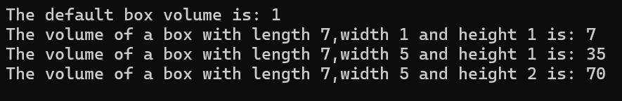

1. Define a function called *area()* with two integer parameters and return the area of the rectangle. By using **function overloading,** overload this function two times, and these overloaded functions’ return types are double. For the first overloaded function, you should calculate the area of the circle, and your function takes one double parameter. The second overloaded function, this function takes two double parameters for calculating the area of the triangle.

In the main function, call these functions as ordered and give parameters, then see the area results of the rectangle, circle, and triangle on the screen.

**Sample Run:**

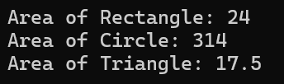

1. Write a function named as *myMAx()* that returns the maximum variable of the related variables. Use a **function template,** anddefine your function that works for all data types. (Do not overload the function. Solve the problem by using a function template, not function overloading.)

**Sample Run:**

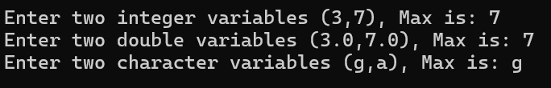

1. Use value and reference passing by defining the functions:

int squareByValue(int); //func. prototype

void squareByReference(int&); //func. prototype

squareByValue multiplies the number by itself, and stores the result, and squareByReference multiplies the numberRef by itself and stores the result.

In the main function,

Call these functions to ensure the output given below.

**Sample Run:**

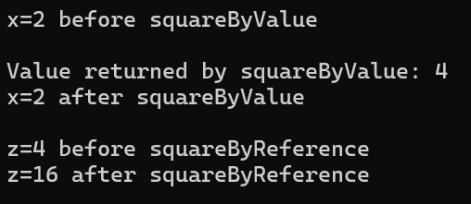

1. Write a boolean function that takes float input as a parameter and compares this input with a global integer variable. The value of a global variable is 7. Check whether the parameter and global value are the same, then return it in the result. (Use the same name for the global variable and function’s parameter.)